# ASSIGNMENT -4

# Question 1:

Pull an image from docker hub and run it on docker playground.

$ docker pull uifd/ui-for-docker

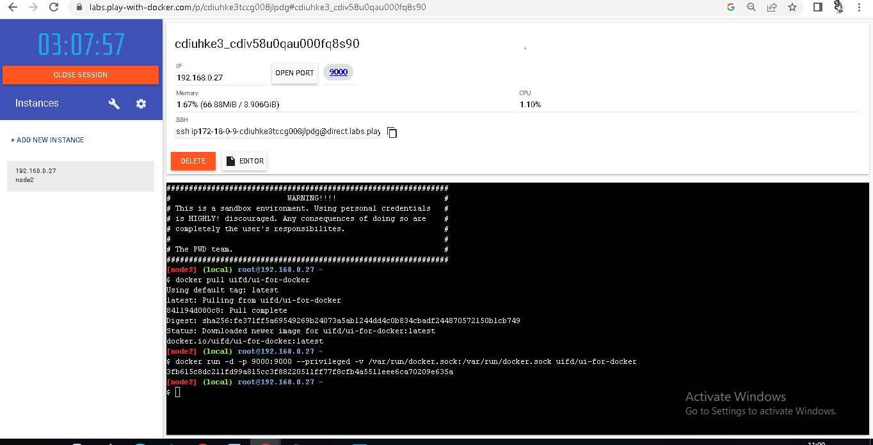

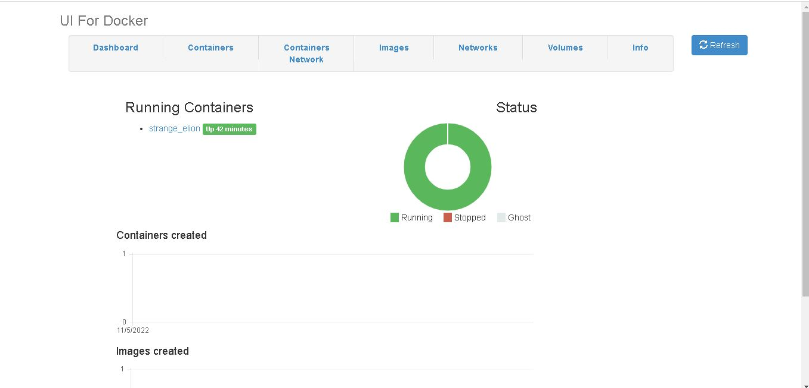

# Question 2:

Create a docker file for the job portal app or hello world app and deploy it in docker desktop app.

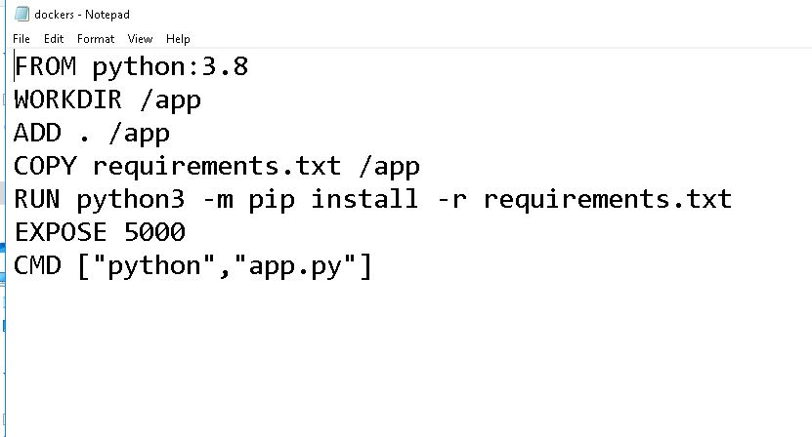

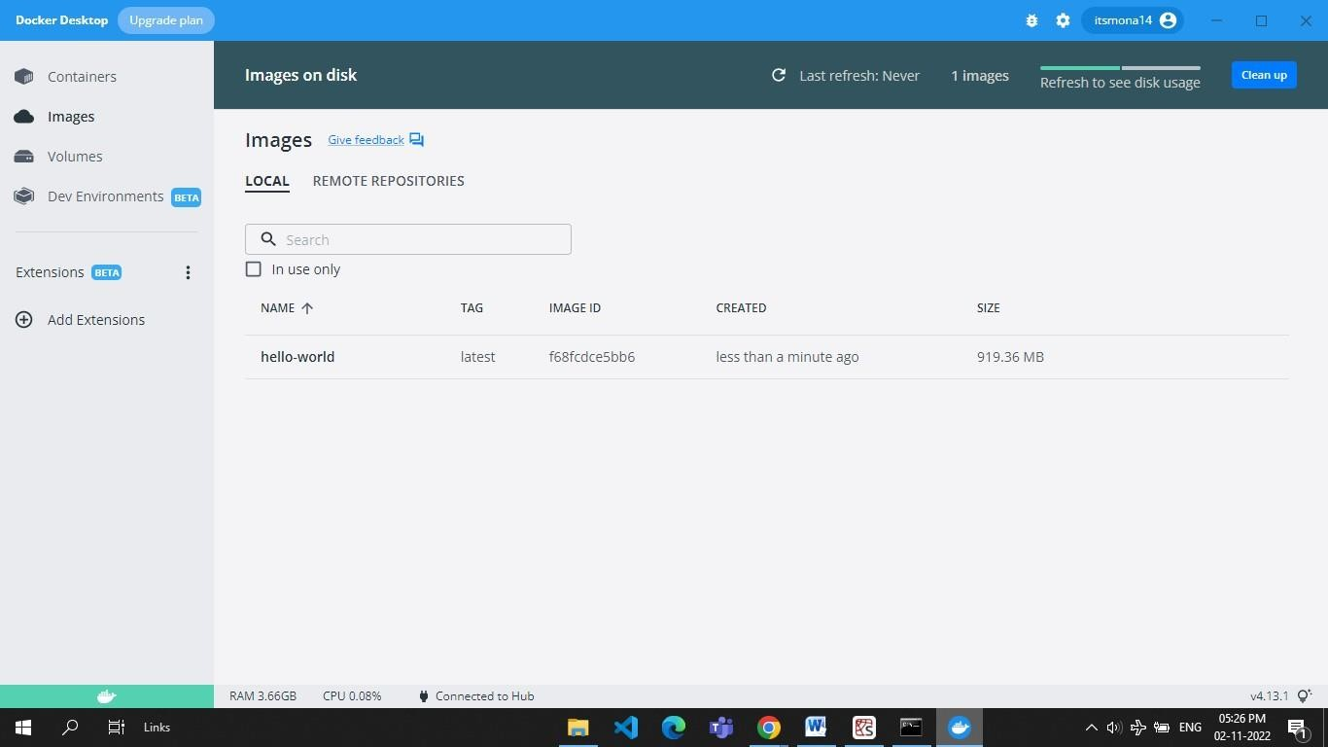

**Question 3:**

Create an IBM container registry and deploy helloworld app or job portal app.

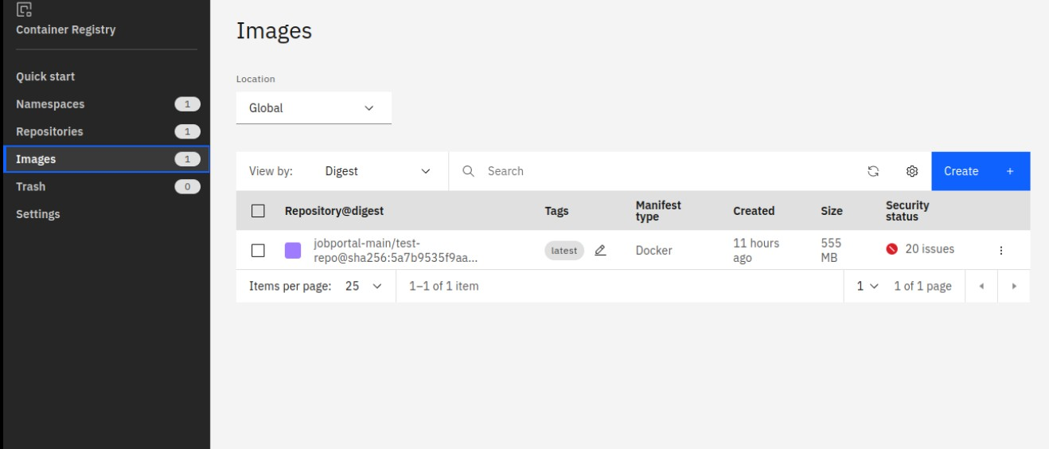

# Question 4:

Create a kubernetes cluster in IBM cloud and deploy helloworld image or jobportal image and alsoexpose the same app to run in nodeport.

apiVersion: v1kind:

Service metadata:

name: hello-world- deploymentspec:

ports:

- port: 5000 targetPort:

5000selector: app: hello-world

---

apiVersion: apps/v1kind: Deployment metadata:

name: hello-world- deploymentspec:

replic as: 1 select or:

matchLabels: app: hello-

worldtemplate: meta

da ta

:

la be ls

:

app: hello- worldspec:

containers:

- name: hello-world

image: au.icr.io/hello-world-app/hello- worldimagePullPolicy: Always

ports:

- containerPort: 5000

